Another successful edition of the European Cyber Security Challenge concluded in Romania

The sixth edition of the European Cyber Security Challenge (ECSC), organised from 9 to 11 October in Bucharest at the Palace of the Parliament, the heaviest building and the second-largest building in the world, has concluded. Team Romania - followed by Italy and Austria - has proven successful in completing the most advanced and complex cybersecurity challenges and is thereby the proud winner of ECSC2019.

Published on October 11, 2019

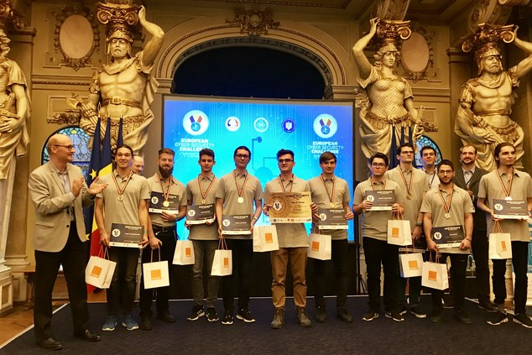

Tagged with

* [Cybersecurity Education](https://www.enisa.europa.eu/search?Subject%3Alist=Cybersecurity%20Education)
* [ENISA(European Union Agency for Cybersecurity)](https://www.enisa.europa.eu/search?Subject%3Alist=ENISA%28European%20Union%20Agency%20for%20Cybersecurity%29)
* [cybersecurity](https://www.enisa.europa.eu/search?Subject%3Alist=cybersecurity)
* [Cyber Crisis Management](https://www.enisa.europa.eu/search?Subject%3Alist=Cyber%20Crisis%20Management)

The competition brought together about 200 young cyber talents from 20 countries (EU Member States and EFTA countries) to prove their abilities in web and mobile security, crypto puzzles, reverse engineering, forensics and escape room. The participants also had to deliver public presentations to a Jury composed of five cybersecurity experts demonstrating soft skills such as teamwork and public speaking under time pressure. With the Netherlands, Ireland and Luxembourg joining, the event is increasing in size and maturity.

In a world, that is changing fast, young people hold the key to innovation. The ENISA European Cyber Security Challenge was born out of this philosophy to encourage young people to pursue a career in cybersecurity.

Every year we create something unique, connecting young minds in shaping the future and improving our lives through technology.

The 2019 edition of the Challenge was opened by the Romanian Minister of Communication and Information Society, Mr. Alexandru Petrescu at the prestigious Palace of the Parliament of Bucharest.

Next, Demosthenes Ikonomou, Head of Operational Security at the EU Agency for Cybersecurity said at the opening ceremony: “We are committed to continuously improve and grow the European Cyber Security Challenge. For the last four years, volunteers from different countries have hosted the event. This year’s edition is the largest in terms of organisation and participants. We thank the Romanian hosts for their hard work that lead to the final and recognise the team efforts to bring this competition alive. Moreover, the ECSC falls during the Cybersecurity Month, a month dedicated to bring awareness on cybersecurity. Through the ECSC we are hoping that the pool of talents will be bigger as the competition matures in Europe.”

Martina Lindorfer opened the award ceremony and gala dinner emphasising that “teaching methods, such as CTFs, can help attract students to the field. It is important to provide incentives for students to pursue their education, as well as a career in academia to avoid the brain drain that is happening in other fields, such as AI. Especially when it comes to security and privacy, we need open science that is not controlled by the big tech giants.”

In this context, as a female role model, Martina Lindorfer enhances the ECSC as a platform for encouraging young girls to participate and pursue a career in the cybersecurity sector. Moreover, she welcomes the introductory presentation on the topic of women in cyber in the context of the ECSC to the audience.

Congratulations to all participants, organisers, visitors and contributors for making this another successful European Cyber Security Challenge! It takes persistence, dedication, and vision to win!

Next year, the Challenge will be organised in Vienna, Austria from 3 to 7 November 2020. Save the date and stay tuned on #ECSC2020 and the renewed website [www.ecsc.eu](http://www.ecsc.eu) ! See you next year.

**More information on how to join the ECSC online campaign**

* ECSC trailer [video](https://www.youtube.com/watch?v=j3JpbPpVXos&t=14s)
* The official hashtag of the European Cyber Security Challenge is #ECSC2019.
* Visit the official site [www.ecsc.eu](http://www.ecsc.eu)
* Follow on Twitter [@enisa_eu](https://twitter.com/enisa_eu?ref_src=twsrc%5Egoogle%7Ctwcamp%5Eserp%7Ctwgr%5Eauthor)

The European Cyber Security Challenge is a project facilitated by the EU Agency for Cybersecurity ENISA, the participating countries and supported by the European Commission.

For media inquiries about this event please contact [press@enisa.europa.eu](http://press@enisa.europa.eu). Please check [www.ecsc.eu](http://www.ecsc.eu) for more information, or contact us at [ecsc@enisa.europe.eu](http://ecsc@enisa.europe.eu).